A Philosophical Critique on Academic Methods of Financial Valuation

Aditya Mishra
22 November, 2025

Abstract. This paper discusses the scope of academic valuation methods such as the “Discounted Cash Flow” Model and the “Gordon Growth” Model (commonly known as the “Dividend Discount” Model). It seeks to establish that these “academic” models provide theoretical solace but lack practical use over long time horizons. The focus is on understanding the role of such models in evaluating businesses for common and preferred stock investments.

- Introduction to Valuation : The Importance of a Great Price

A good investment is not simply defined by the quality of the investment, but is also defined by the price incurred to make that investment. Overpaying, while buying anything, whether for produce, or for a business, poses a significant threat to the potential returns on that investment. Hence, finding the intrinsic value of a business is an important step in evaluating potential capital distributions.

Illustration 1. The Case of Amazon Inc. during the dot-com mania.
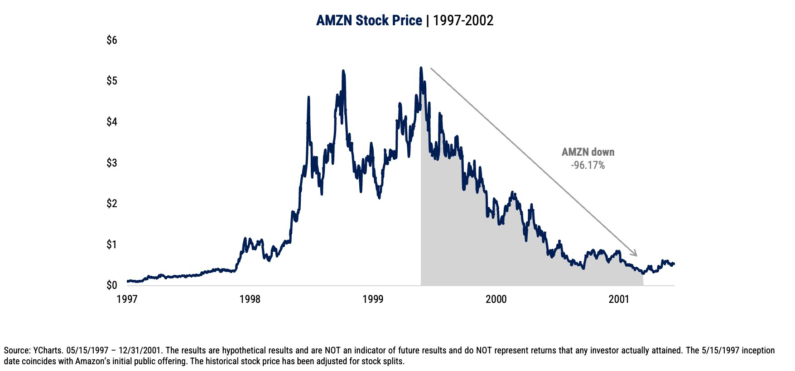
Before the year 2000, Amazon showed financial strength primarily through liquidity ratios such as a current ratio around or above one, indicating its capacity to cover short-term obligations; operating efficiency reflected in a negative cash conversion cycle; and evolving profitability ratios despite low net income due to heavy reinvestment and expansion costs. Amazon showed rapid user growth, improving operational efficiency, disciplined leadership, and relentless long-term focus.​ Amazon was a quality “darling”. Any investor who simply focused on quality, and ignored valuations, faced the full brunt of the “TMT” (Tech Media Telecom, commonly known as “dot-com bubble”) frenzy. But, the valuation of Amazon was anything but “darling”. Amazon, in 1999, had an enterprise value to revenue (EV/Revenue) multiple often estimated above 10x, reflecting high investor expectations based on growth rather than earnings. Adjusting Amazon’s 1999 EV/Revenue multiples to 2025 dollars with CPI inflation implies that an EV/Revenue multiple of 12x in 1999 corresponds to an estimated 23.42 by September 2025. This means, adjusted for today, the entire company was valued at 23 times the revenue it produces in one year. A steep price.

If an unassuming investor had bought common stocks of Amazon, in 1999, by 2002, his holdings would have deteriorated by 96.17%. This means, $10,000 would correct to $383. Amidst all this, Amazon the company was still shipping packages, and was still restocking warehouses, but Amazon the stock was, as it seemed, going nowhere.

This illustration shows how a good business can turn out to be a terrible investment.

- Introduction to “Academic” Valuation Methods : An Illusion of Certainty

Academic valuation methods for evaluating the “worth” of a business involve
three basic steps:
- Forecasting
- Discounting
- Comparing
And these three steps are performed using:
- Historical Data
- Assumptions
Together these processes form the “Academic” way of evaluating the intrinsic value of a business. On the surface, this way of valuation seems “clean” and efficient, but once investigated further, glaring faultlines emerge. Over dependence on past data, and assumptions prove to give a false sense of certainty, which is dangerous in the capital markets

Illustration 2: Trouble at Long Term Capital Management Inc.

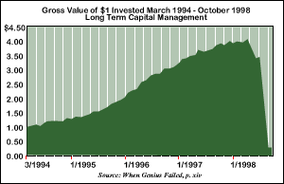

Long-Term Capital Management (LTCM) was founded in 1994 by John Meriwether, a former Salomon Brothers bond trader, and included key personnel such as Nobel Prize-winning economists Myron Scholes and Robert C. Merton, along with other principals like David W. Mullins Jr., Larry Hilibrand, Victor Haghani, and Eric Rosenfeld. LTCM was a highly leveraged hedge fund that used sophisticated quantitative models to exploit small price differences in related financial instruments through arbitrage strategies.
LTCM used historical data by analysing past market price movements, correlations, and volatilities to estimate the probabilities of future price changes and identify arbitrage opportunities. Their models assumed asset prices followed stable, normally distributed patterns (ergodicity) and that historical relationships would persist, shaping their strategy of convergence trades expecting prices to revert to historical norms. These assumptions led LTCM to rely heavily on quantitative models calibrated on limited historical data, which influenced their deployment of high leverage and convergence arbitrage strategies.

LTCM crashed due to its overreliance on historical data and assumptions that market conditions would revert to past norms; when the 1997 Asian financial crisis and 1998 Russian default triggered unprecedented market volatility and a "flight to liquidity," LTCM's models failed to anticipate the scale and persistence of these events. This caused the spreads they bet on to diverge instead of converge, forcing massive losses. Their assumptions of normal market behaviour, stable correlations, and high liquidity proved wrong, magnifying losses and making it impossible to liquidate positions without severe market impact, resulting in a rapid deterioration of capital and requiring a bailout to avoid systemic financial disruption.

The case of LTCM is a reminder that the markets may seem “foreseeable”, when viewed through sophisticated models, being blinded by an illusion of certainty is obvious and being swept by it, is imminent.

- The Discounted Cashflow model

  - Introduction

In discounted cashflows valuation, the value of an asset is the present value of the
expected cashflows on the asset, discounted back at a rate that reflects the riskiness of these cashflows. This approach gets the most play in academia and comes with the best theoretical credentials.

  - Method

First, analysts project the company’s cash flows over a certain period, usually 5–10 years, based on revenue, costs, and investments. Next, these future cash flows are adjusted to their present value using a discount rate, which reflects the time value of money and risk. Often, a terminal value is calculated to capture the value beyond the projection period, assuming a steady growth rate. Finally, the present value of the projected cash flows and the discounted terminal value are added together to determine the intrinsic value of the company.
Illustration 3. The Case of XYZ Inc.
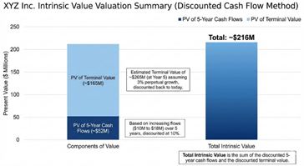
XYZ Inc is expected to generate cash flows starting at $10 million next year and growing to $18 million in five years. Discounting these future cash flows at 10% gives a present value of about $52 million. Assuming the company continues to grow
at 3% afterward, the discounted terminal value adds roughly $165 million. Together, this implies that the intrinsic value of XYZ Inc is around $216 million.
Illustration 3 shows how easily the illusion of certainty creeps in when dealing with such models.
Note: Illustrative calculations are simplified for conceptual clarity

  - The Illusion

On changing the assumptions of illustration 3 by merely 5%, the intrinsic value of XYZ Inc. becomes $182.8 million. These differences can greatly influence important aspects of investing like maintaining a margin of safety.

The sensitive nature of assumptions underscores the reliability of such models, which sell the illusion of certainty.

Discounted Cash Flow (DCF) analysis is widely used but criticized for its heavy reliance on assumptions, small errors in forecasting cash flows, discount rates, or terminal values can lead to vastly different valuations. It assumes accurate long-term predictions of cash flows and growth, which is often unrealistic due to market volatility and unforeseen changes. The model also heavily weights terminal value, which can constitute up to 80% of the total valuation, making results sensitive to assumptions about perpetual growth. Moreover, DCF can encourage overly optimistic forecasts and struggles with the untestable nature of its assumptions, potentially leading to misleading valuations.

- The Gordon Growth Model

4.1 Introduction

The Gordon Growth Model (GGM) or the Dividend Discount model is a method used to determine the intrinsic value of a stock based on the assumption that dividends will grow at a constant rate indefinitely. It calculates the present value of future dividends, helping investors assess whether a stock is undervalued or overvalued.

4.2 The Method

The model assumes that dividends will grow at a constant rate indefinitely, allowing the value of the stock to be expressed as the present value of all future dividends. To apply the model, the next expected dividend is divided by the difference between the required rate of return and the assumed constant growth rate. This method provides a straightforward and intuitive way to determine the value of a dividend-paying company, particularly when growth is stable and predictable.
Illustration 4: The case of ZYX Inc

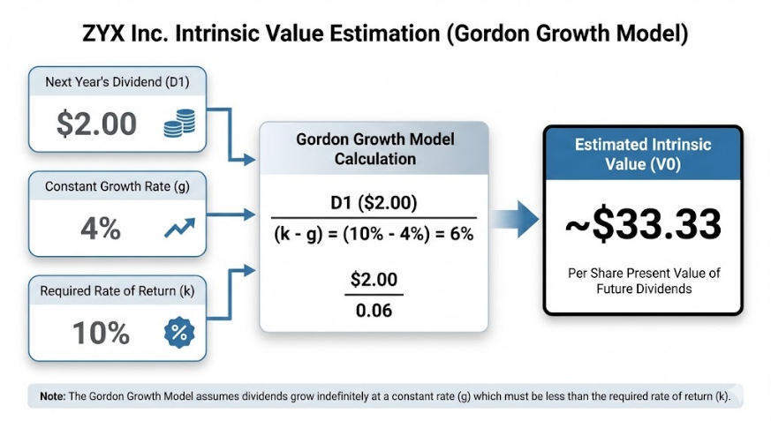

ZYX Inc is expected to pay a dividend of $2 per share next year, and its dividends are projected to grow steadily at 4% per year. If investors require a return of 10% to invest in the stock, the Gordon Growth Model can be used to estimate the intrinsic value. Using this approach, the value of ZYX Inc is found to be around $33 per share, reflecting the present value of all future dividends under the assumed growth and return rates.
Note: Illustrative calculations are simplified for conceptual clarity

4.3 The Illusion

On changing the assumptions of the ZYX Inc. illustration by adjusting either the dividend growth rate or the required return by 5 percentage points, the intrinsic value can swing dramatically, from around $18 per share to as high as $200 per share. Such differences underscore how sensitive valuation models are and highlight the importance of maintaining a margin of safety in investment decisions.

The main drawbacks of the Gordon Growth Model (GGM) include its assumption of a constant perpetual growth rate which is often unrealistic, especially when the growth rate approaches or exceeds the discount rate; its sensitivity to input values where small changes in growth or discount rates cause large valuation swings; reliance on stable dividends, making it unsuitable for companies with irregular payout policies; and inability to value firms with no dividends or during non-constant growth phases, limiting its applicability to a narrow set of mature, stable companies.

- Conclusion & References
The purpose of this paper was to never undermine the mathematical prowess of the financial models discussed, instead it was to show the impracticality possessed by these models, in the real world. There lies no certainty in the capital markets. Clean numbers, long forecasts, and efficient discount rates are found only on paper.
But of course, nuance is necessary. For every LTCM, there is a Renaissance Technologies. What matters is not what you use, but how much you use it. In their own right, academic methods of valuations pose a good framework to broadly understand business dynamics, and frame investment thesis. What is necessary is to look beyond the formulas, and look to the business. For what is being bought is a business, not a rulebook.
In the end, determining the intrinsic value of a business is more of a thought experiment, than a mathematical endeavour. History has shown this, and the future will too. Mathematics broadly works in efficient systems; the capital markets are anything but that.
References
- Finance Yahoo. (2023, September 18). Global market crash sparks reflection. Yahoo Finance. https://finance.yahoo.com/news/global-market-crash-sparks-reflection-150704777.html
- Harvard Business School Online. (2023). How Amazon survived the dot-com bubble. https://online.hbs.edu/blog/post/how-amazon-survived-the-dot-com-bubble
- Arka Jain University. (2021). AJU211103 BBA documents. https://arkajainuniversity.ac.in/naac/Criteria%201/1.3.4/1_3_4_DOCUMENTS/BBA/AJU211103.pdf
- StatMuse Amazon P/E ratio 1999. https://www.statmuse.com/money/ask?q=amazon+p%2Fe+ratio+1999
- Wikipedia. (2023). Long-Term Capital Management. https://en.wikipedia.org/wiki/Long-Term_Capital_Management
- Bauer College of Business, University of Houston. (2023). Long-Term Capital Management case study. https://www.bauer.uh.edu/rsusmel/7386/ltcm-2.htm
- Harvard Law School Forum on Corporate Governance. (2022, April 20). The DCF valuation methodology is untestable. https://corpgov.law.harvard.edu/2022/04/20/the-dcf-valuation-methodology-is-untestable/
- Janav. (2015, May 1). Geometric series and Gordon growth model. https://janav.wordpress.com/2015/05/01/geometric-series-and-gordon-growth-model/

